COMHAIRLE CHONTAE AN LONGFOIRT

LONGFORD COUNTY COUNCIL

Corporate Affairs,
Aras an Chontae,
LONGFOIRT.

16th February 2016.

To: The Cathaoirleach and Members of Longford County Council

A Chomhairleoir,

Councillor Gerry Warnock, Cathaoirleach, has been requested by the following Councillors - Mark Casey, Martin Mulleady, Mae Sexton, Pat O’Toole,
Padraig Loughrey and Gerry Warnock -
to convene a Special Meeting of Longford County Council regarding the unsuccessful appeal by St. Christopher’s to the National Council for Special Education to have the vital SNA positions reinstated. And the continuous cuts that St. Christophers have had in the last number of years.

The meeting will be held on Monday, 22nd February 2016 at 6.00 p.m. in the Council Chamber, Aras an Chontae, Great Water Street, Longford

Copy of request attached.

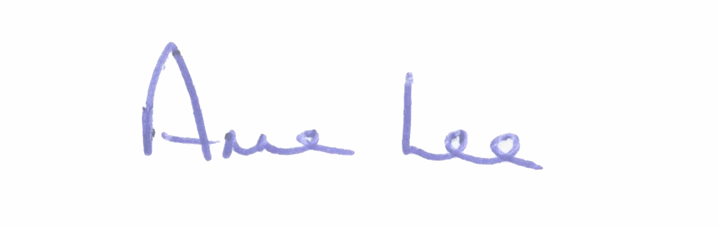
Mise le meas,

Anne Lee
Meetings Administrator.

Encl.

